

Calculation Policy adapted from White Rose Maths Hub

Progression in Calculations, expectations for all year groups and vocabulary for Dunchurch Federation of Schools and Leamington Hastings Infant School
July 2019

Year Group Expectations for Place Value, Number and Counting | Year 1  - Read and write numbers from 1 to 20 in numerals and in words.  - Begin to read and write numbers to 100 in numerals and in words.  - Order numbers from 0 up to 50, including non-consecutive numbers.  - Begin to recognise place value in numbers to and beyond 20 using concrete objects and pictorial representations (10s and 1s).  - Given any number to 100, identify 1 more and 1 less  - Find 10 more and less than a teen number.  - Use the language of: equal to, more than, less than and fewer when comparing groups of objects.  - Compares numbers supported by concrete and pictorial representations, using the <, > and = signs.  - Identify and represent numbers using objects and pictorial representations including the number line, and use the language of: equal to, more than, less than (fewer), most, least when comparing numbers  Counting  - Count to and across 100, forwards and backwards, beginning with 0 or 1, or from any given number (in 1s).  - Count, read and write numbers to 100 in numerals.  - Count forwards in multiples of 2s, 5s and 10s independently.  - Use ordinal numbers from 1st to 10th . | Year 2  - Read and write numbers to at least 100 in numerals and in words.  - Order numbers from 0 up to 100, including non-consecutive numbers  - Recognise the place value of each digit in any two-digit number (10s and 1s) and partition and construct numbers.  - Understand 0 as a placeholder.  - Partition 2 digit numbers in different ways e.g. 42 = 40 + 2, 30 + 12, 20 + 22, 10 + 12.  - Find 10 more and less than a number to 100.  - Compare 2 digit numbers to 100 and use <, > and = signs in a range of contexts, including concrete, pictorial and abstract representations  - Identify, represent and estimate numbers using different representations, including the number line when comparing number to 100.  Counting  - Count in steps of 2, 3, and 5 from 0, and in 10s from any number, forward and backward.  - Solve problems involving the use of ordinal numbers.
Nursery- rising 3s
- Creates and experiments with symbols to represent and marks to represent ideas of a number.
- Begins to match the numerals 1 to 3 to concrete objects.
- Recites some number names in sequence e.g. 1, 2, 3.
- Begin to recognise more and getting bigger and less as getting smaller.
- Begin to make comparisons between quantities e.g. that group has a lot.
- Find the numbers 1 to 3 on a printed number line.
Counting
- Realises not only objects but anything can be counted e.g. claps, steps or jumps.
- Selects a small number of objects from a group when asked to e.g. can you pass me 1, can you pass me two.
- Counts up to 3 objects, saying a number name for each item.
- Begin to recognise the arrangements on a dice face for 1, 2 and 3.
- Recites some number names in sequence e.g. 1, 2, 3.
- Recites numbers in order to 10. | Year 3  - count from 0 in multiples of 4, 8, 50 and 100; find 10 or 100 more or less than a given number  - recognise the place value of each digit in a three-digit number (hundreds, tens, ones)  - compare and order numbers up to 1000  - identify, represent and estimate numbers using different representations  - read and write numbers up to 1000 in numerals and in words  - solve number problems and practical problems involving these ideas | Year 4  - count in multiples of 6, 7, 9, 25 and 1000  - find 1000 more or less than a given number  - count backwards through zero to include negative numbers  - recognise the place value of each digit in a four-digit number (thousands, hundreds, tens, and ones)  - order and compare numbers beyond 1000  - identify, represent and estimate numbers using different representations  - round any number to the nearest 10, 100 or 1000  - solve number and practical problems that involve all of the above and with increasingly large positive numbers  - read Roman numerals to 100 (I to C) and know that over time, the numeral system changed to include the concept of zero and place value.
Reception  - Recognises numerals from 0 to 20.  - Read and write numerals to 20  - Order numbers from 1 to 20 both forwards and backwards.  - Find 1 more and less than a number to 20.  - Consistently uses the language of more and less than to compare two sets of objects.  - Begin to use the language of: equal to, more than, less than and fewer to compare two sets of objects.  - Begin to identify and represent numbers using objects and pictorial representations including the number line, and use the language of: equal to, more than, less than (fewer), most, least using numbers to 20.  Counting  - Count objects from 1 to 20 reliably.  - Counts forwards and backwards in 1s to 20.  - Counts an irregular pictorial arrangement of up to 20 objects.  - Children estimate a number of objects and check quantities by counting up to 20.  - Subitise up to 10 using the arrangements of a tens frame and numicon tiles.  - Count forwards in 2s, 5s and 10s as a class. | Year 5  - read, write, order and compare numbers to at least 1 000 000 and determine the value of each digit  - count forwards or backwards in steps of powers of 10 for any given number up to 1 000 000  - interpret negative numbers in context, count forwards and backwards with positive and negative whole numbers, including through zero  - round any number up to 1 000 000 to the nearest 10, 100, 1000, 10 000 and 100 000  - solve number problems and practical problems that involve all of the above  - read Roman numerals to 1000 (M) and recognise years written in Roman numerals. | Year 6  - read, write, order and compare numbers up to 10 000 000 and determine the value of each digit  - round any whole number to a required degree of accuracy  - use negative numbers in context, and calculate intervals across zero  - solve number and practical problems that involve all of the above

Year Group Expectations in Addition and Subtraction | Nursery – rising 3s  - Separate a group of 3 or objects in different ways.  - Knows that a group of things changes in quantity when something is added.  - Separate a group of 3 or 4 objects in different ways.  - Knows that a group of things changes in quantity when something is taken away.
 | Nursery – Pre school  - Separates a group of up to 6 objects in different ways, beginning to recognise that the total stays the same.  - Finds the total number of items in two groups by counting all of them.  - Separates a group of up to 6 objects in different ways, beginning to recognise that the total stays the same.  - Counts out a small set of objects before and after something has been taken away. | Reception  - Represent number bond families to 10 using concrete and pictorial representations.  - Read, write and interpret mathematical statements involving addition (+) and equals (=) signs.  - Add 2 single digit numbers, counting on to find the answer using quantities, objects and the number line.  - Begin to understand that addition of 2 numbers is commutative.  - Begin to solve missing number problems using concrete objects.  - Represent number bond families to 10 using concrete and pictorial representations. (subtraction)  - Read, write and interpret mathematical statements involving subtraction (−) and equals (=) signs.  - Subtract 2 single digit numbers counting back to find the answer using quantities, objects and the number line.  - Begin to understand that subtraction is not commutative.  - Begin to solve missing number problems using concrete objects
 | Year 1  - Represent and use number bonds families within 10 to solve problems.  - Recall and use addition facts to 10 fluently.  - Read, write and interpret mathematical statements involving addition (+) and equals (=) signs, including the = signs in different positions such as 12 = 7 + 5.  - Add one-digit and two-digit numbers up to a total of 40, including the effect of adding 0.  - Solve one-step problems that involve addition using concrete objects and pictorial representations  - Understand that addition of 2 numbers is commutative.  - Solve missing number problems using concreate objects and pictorial representations.  - Represent and use related number bond family subtraction facts within 10.  - Recall and use subtraction facts to 10 fluently.  - Read, write and interpret mathematical statements involving subtraction (−) and equals (=) signs, including the = signs in different positions such as 12 = 16 - 4.  - Subtract one-digit and two-digit numbers from 40, including the effect of subtracting 0.  - Develop an understanding of ‘find the difference’  - Solve one-step problems that involve subtraction using concrete objects and pictorial representations  - Understand that subtraction is not commutative.  - Solve missing number problems using concreate objects and pictorial representations. | Year 2  - Represent and use number bonds families within 20 to solve problems.  - Recall and use addition facts to 20 fluently, and derive and use related facts up to 100.  - Add numbers using concrete objects, pictorial representations, and mentally, including: a two-digit number and 1s a two-digit number and 10s,2 two-digit numbers, adding 3 one-digit numbers.  - Solve problems with addition using concrete, pictorial and abstract representations, including those involving numbers, quantities and measures, applying their increasing knowledge of mental and written methods.  - Solve two – step word problems (GD).  - Demonstrate that addition of numbers is commutative by providing own examples.  - Recognise and use the inverse relationship between addition and subtraction and use this to check calculations and solve missing number problems.  - Use reasoning about numbers and relationships to solve more complex problems and explain their thinking (e.g. 29 + 17 = 15 + 4 + ? 38 + 15 = ? + 6 (GD).  - Represent and use related number bond family subtraction facts within 20.  - Recall and use subtraction facts to 20 fluently, and derive and use related facts up to 100.  - Subtract numbers using concrete objects, pictorial representations, and mentally, including: a two-digit number and 1s, a two-digit number and 10s, 2 two-digit numbers.  - Solve problems involving difference.  - Solve problems with subtraction using concrete objects and pictorial representations, including those involving numbers, quantities and measures, applying their increasing knowledge of mental and written methods.  - Solve two – step word problems (GD).  - Demonstrate that subtraction of numbers is not commutative by providing own examples  - Recognise and use the inverse relationship between addition and subtraction and use this to check calculations and solve missing number problems.  - Use reasoning about numbers and relationships to solve more complex problems and explain their thinking (e.g. 32 - 17 = 15 - 4 - ? 38 - 15 = ? - 6 (GD).
 | Year 3  - add and subtract numbers mentally, including:  a three-digit number and ones  a three-digit number and tens  a three-digit number and hundreds  - add and subtract numbers with up to three digits, using formal written methods of columnar addition and subtraction  - estimate the answer to a calculation and use inverse operations to check answers  - solve problems, including missing number problems, using number facts, place value, and more complex addition and subtraction. | Year 4  - add and subtract numbers with up to 4 digits using the formal written methods of columnar addition and subtraction where appropriate  - estimate and use inverse operations to check answers to a calculation  - solve addition and subtraction two-step problems in contexts, deciding which operations and methods to use and why
 | Year 5  - add and subtract whole numbers with more than 4 digits, including using formal written methods (columnar addition and subtraction)  - add and subtract numbers mentally with increasingly large numbers  - use rounding to check answers to calculations and determine, in the context of a problem, levels of accuracy  - solve addition and subtraction multi-step problems in contexts, deciding which operations and methods to use and why. | Year 6  - solve addition and subtraction multi-step problems in contexts, deciding which operations and methods to use and why  - use their knowledge of the order of operations to carry out calculations involving the four operations  - perform mental calculations, including with mixed operations and large numbers

Year Group Expectations in Multiplication and Division | Nursery-Pre School  - Begin to understand the term double as having the same again with a small amount of objects.  - Begin to understand the term half as splitting a small amount of objects into 2 equal groups | Reception  - Mentally recall doubles to 10.  - Solve problems involving doubles using concrete objects.  - Solve practical problems that involve combining groups of 2, 5 or 10 (EX).  - Mentally recall halves from 10.  - Solve problems involving sharing using concrete objects.  - Solve practical problems that involve sharing into equal groups.
 | Year 1  - Mentally recall doubles to 10 and use this to solve problems using concrete objects and pictorial representations.  - Count forwards in multiples of 2s, 5s and 10s.  - Use arrays to represent repeated addition questions, counting in 2s 5s and 10s.  - Make connections between arrays, number patterns and counting in 2s 5s and 10s.  - Solve one-step problems involving multiplication by calculating the answer using concrete objects, pictorial representations and arrays.  - Mentally recall halves from 10 and use this to solve problems, using concrete objects and pictorial representations.  - Use arrays practically to represent division questions in 2s 5s and 10s  - Solve one-step problems involving division, by calculating the answer using concrete objects, pictorial representations and arrays.  - Solve problems involving grouping and sharing. | Year 2  - Mentally recall doubles to 20 and use this to solve problems  - Count in steps of 2, 3, and 5 from 0, and in 10s from any number, forward and backward.  - Calculate mathematical statements for multiplication within the multiplication tables and write them using the multiplication (×) and equals (=) signs.  - Recall and use multiplication and facts for the 2, 5 and 10 multiplication tables.  - Connect the tens multiplication tables to place value and the 5s to counting on a clock face.  - Begin to calculate multiplication facts beyond 2, 5 and 10  - Show that multiplication of 2 numbers can be done in any order (commutative) and division of 1 number by another cannot.  - Solve problems involving multiplication using materials, arrays, repeated addition, mental methods, and multiplication facts, including problems in contexts.  - Use multiplication facts to make deductions outside known multiplication facts, e.g. know that multiples of 5 have one digit of zero or 5 and use this to reason that 18 x 5 cannot be 92 because it does not end in a 5 or a 0 (GD).  - Recognise and use the inverse relationship between multiplication and division and use this to check calculations and solve missing number problems.  - Use reasoning about numbers and relationships to solve more complex problems and explain their thinking (e.g. 6 x 10 = ? x 5 ? x 2 = 8 x 5 (GD).  - Mentally recall halves from 20 and use this to solve problems.  - Calculate mathematical statements for division within the multiplication tables and write them using the division (÷) and equals (=) signs.  - Recall and use and division facts for the 2, 5 and 10 multiplication tables.  - Begin to calculate division facts beyond 2, 5 and 10.  - Calculate remainders when solving division questions (GD).  - Solve problems involving division, using objects, arrays, repeated addition, mental methods, groupings, sharing and division facts, including problems in context.  - Recognise and use the inverse relationship between multiplication and division and use this to check calculations and solve missing number problems.  - Use reasoning about numbers and relationships to solve more complex problems and explain their thinking (e.g. 10 ÷ 2 = 50 ÷ ? ? ÷ 10 = 8 ÷ 2 (GD
 | Year 3  - recall and use multiplication and division facts for the 3, 4 and 8 multiplication tables  - write and calculate mathematical statements for multiplication and division using the multiplication tables that they know, including for two-digit numbers times one-digit numbers, using mental and progressing to formal written methods  - solve problems, including missing number problems, involving multiplication and division, including positive integer scaling problems and correspondence problems in which n objects are connected to m objects | Year 4  - recall multiplication and division facts for multiplication tables up to 12 × 12  - use place value, known and derived facts to multiply and divide mentally, including multiplying  by 0 and dividing by 1; multiplying three number  - recognise and use factor pairs and commutativity in mental calculations  - multiply two-digit and three-digit numbers by a one-digit number using formal written layout  - solve problems involving multiplying and adding, including using the distributive law to multiply  two different numbers by one digit, integer scaling problems and harder correspondence problems  such as n objects are connected to m objects
 | Year 5  - identify multiples and factors, including finding all factor pairs of a number, and common factors of two numbers  - know and use the vocabulary of prime numbers, prime factors and composite (nonprime) numbers  - establish whether a number up to 100 is prime and recall prime numbers up to 19  - multiply numbers up to 4 digits by a one- or two-digit number using a formal written method, including long multiplication for two-digit numbers  - multiply and divide numbers mentally drawing upon known facts  - divide numbers up to 4 digits by a one-digit number using the formal written method of short division and interpret remainders appropriately for the context  - multiply and divide whole numbers and those involving decimals by 10, 100 and 1000 | Year 6  - multiply multi-digit numbers up to 4 digits by a two-digit whole number using the formal written method of long multiplication  - divide numbers up to 4 digits by a two-digit whole number using the formal written method of long division, and interpret remainders as whole number remainders, fractions, or by rounding, as appropriate for the context  - divide numbers up to 4 digits by a two-digit number using the formal written method of short division where appropriate, interpreting remainders according to the context  - perform mental calculations, including with mixed operations and large numbers  - identify common factors, common multiples and prime numbers  - use their knowledge of the order of operations to carry out calculations involving the four operations

Objective and Strategy | Concrete | Pictorial | Abstract
Ordinality | Children place a physical set of dominoes in a set order  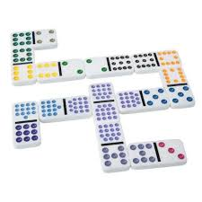 | Children match representations in a set order for example using pictorial bear/number dominoes  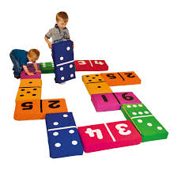 | Children fill in spaces on a partially filled in number track and create representations to show different totals
  1 |  | 3 | 4 |  |  | 7 |  | 9

Ordinal numbers | Concrete | Pictorial | Abstract
 | Children physically line up ducks in a row and count them (1st, 2nd, 3^{rd, 4th})  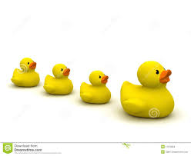 | Children order slides of pictures of ducks for example on the interactive whiteboard | Children apply their understanding of ordinal numbers e.g. using written 1st, 2nd and 3rd labels and other related verbal language when ordering objects  2nd  1stst

Cardinality | Concrete | Pictorial | Abstract
 | Children use a range of structured and unstructured apparatus, plus natural resources, to create different number values  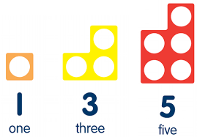  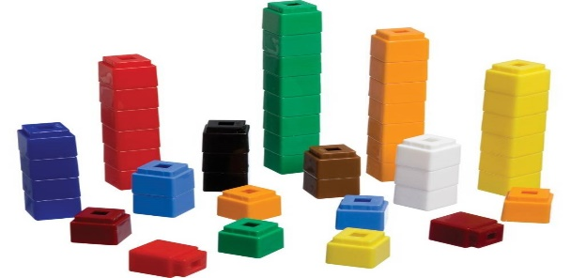 | Children recognise different number values that are presented in pictorial forms  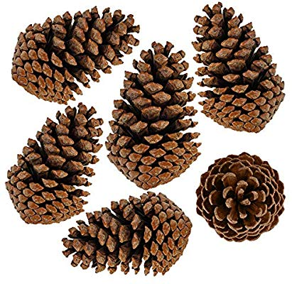 | Children are asked a range of questions that allow them to show an application of understanding related to cardinality, e.g. Can you find a collection of objects to represent six? Can you show me 6 fingers?

Subitising | Concrete | Pictorial | Abstract
 | Children replicate a range of physical representations, which they then verbally interpret without a need to count objects.  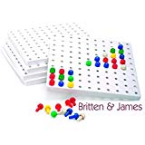 | Children use picture prompts to practise their recognition of number representations.  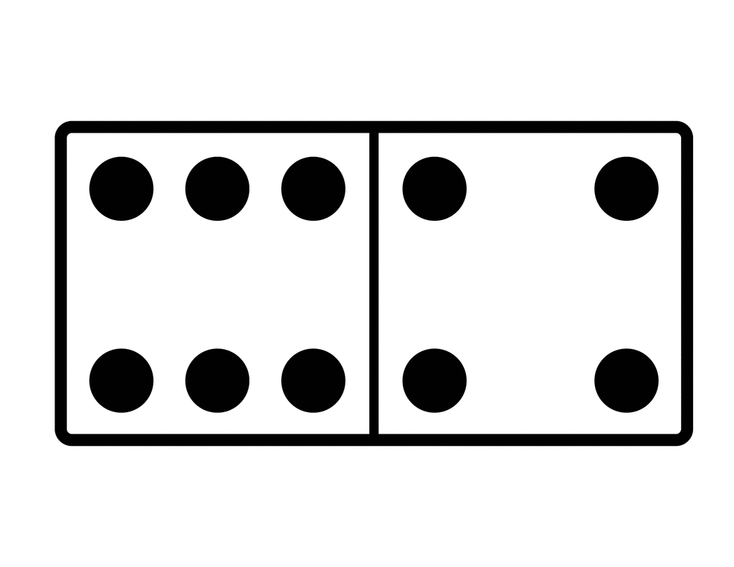 | Children use finger paint to show various representations  

Equality | Concrete | Pictorial | Abstract
 | Children use physical equipment when learning about equality (also inequality) and also use related language e.g. the same as, more than and less than  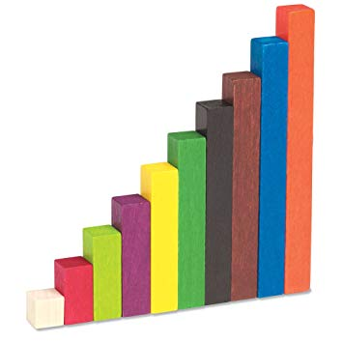 | Children use pictorial representations to show equality or values that are “the same as”, whilst also verbalising their reasoning e.g. “orange is the same as two yellows”  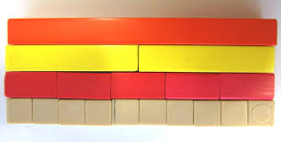 | Children use the part/whole model to record either written numerals or pictorial representations that highlight the concept of “the same as”  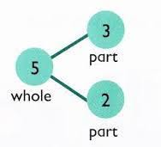

1 to 1 Correspondence | Concrete | Pictorial | Abstract
 | Children count various physical objects by partitioning a group and finally recombining.   | Children count the dots on the face of a dice | Children draw dots to match the number of holes that can be seen on a named Numicon shape  
 | Children write a number in each part of muffin tin and then put the appropriate number of buttons in each section  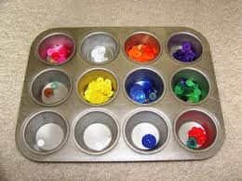 | Children match number cards to pictures of the equal number of buttons  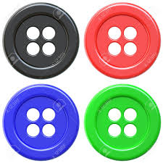 4 buttons | Children cut out buttons equal to the number shown on a number card.  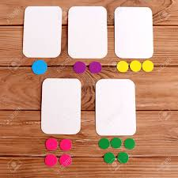  1

Conservation of number | Concrete | Pictorial | Abstract
 | Children explore whether the number of cubes stay the same or change when they are moved within a shape | Pupils work with visual reminders of their concrete experiences – to check how their understanding around conservation of number has changed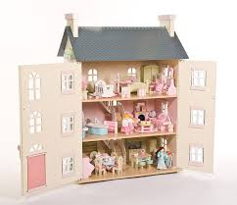 | Children are provided with opportunities to further explore and prove their thinking. They may be asked to put a total of dolls in the toy house and then move them around in order to prove it is still the same total. They can take the dolls and put them on a number track whilst also applying their understanding about the cardinal principle.  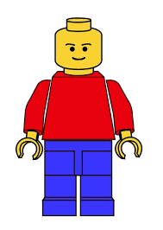  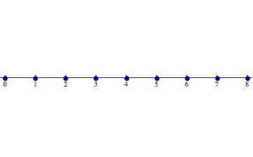

Concept of Zero | Concrete | Pictorial | Abstract
 | Children use a shuffle box with up to ten objects in. After the box has been shaken, pupils write out the corresponding number sentence. Query what happens if there is nothing on one side. Introduce children to the concept of zero. E.g 2=2+0 | Children use pictorial representations to see that you can have an amount that’s called “zero” Pupils are required to count the number of apples on a tree and circle the trees which have no apples.  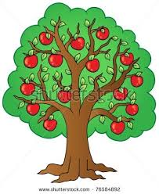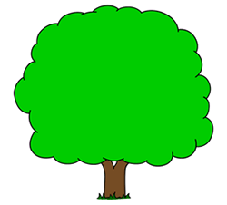 | Children can be encouraged to represent written number sentences by creating visual shuffle boxes using finger paint. E.g 5= 0+5

Key vocabulary for Sorting and Organising | sort, group, set, similar, different

Objective and Strategies | Concrete | Pictorial | Abstract
Sorting and Organising | 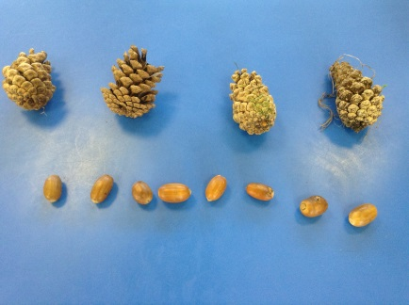  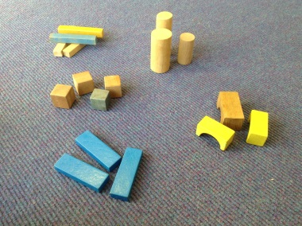  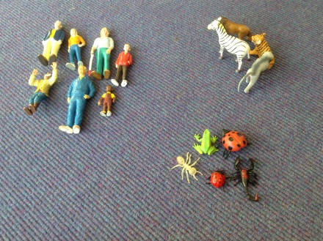 | 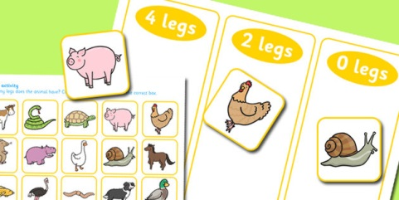  Set of nothing = to 0  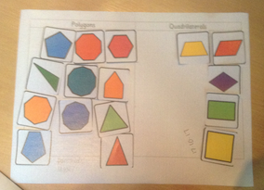  Universal Set  This is a set of shapes  Triangles  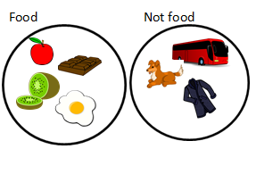  red  triangles | 2 6 4  8  1 7 3  5
  10 | Not 10
  0 + 10  20-10  18-8  3+7  5+4+1 | 5+4  19-8  15+3  4+4-1  6+7

Key vocabulary for Comparing Quantities | more, less, the same, greater, fewer, equal to, equivalent, equal values

Objective and Strategies | Concrete | Pictorial | Abstract
Comparing Quantities | 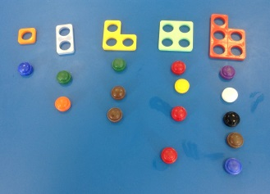  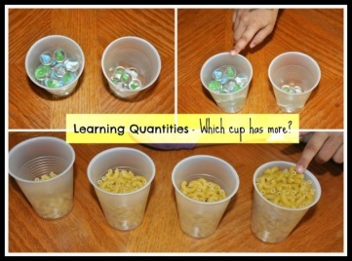  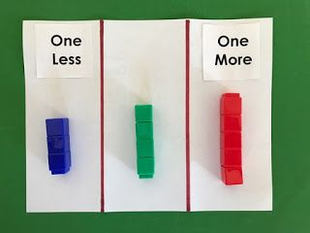  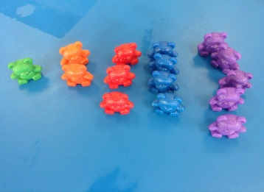  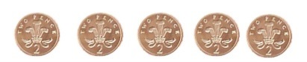  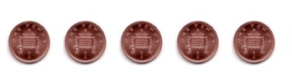 | 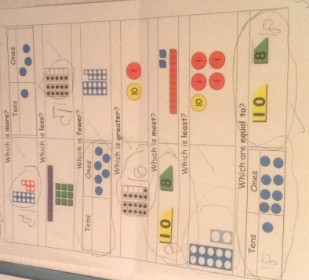  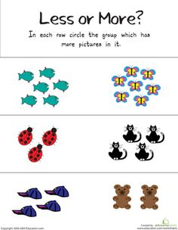  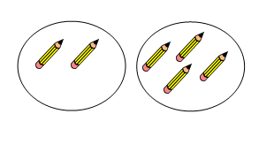  Children could use their own drawings to show more/less. | Using symbols < > and =  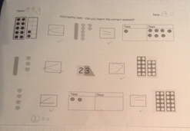

Addition and Subtraction
Key Vocabulary for addition and subtraction | More than, add, addition, added total, plus, altogether, more, is equal to, equals, is the same as, parts and wholes, sum  Difference, greater than, less than, equivalent, Number bond, balance, bigger, more, larger, commutative, missing numbers, digits, inverse, operation, addend, fact family, balance, take away, taken away, left, smaller, less, fewer, subtract, subtraction, subtracted

Objective and Strategies | Concrete |  | Pictorial | Abstract
Combining two parts to make a whole: part- whole model (use resources too. E.g eggs, shells, teddy bears)  (  Understandin g concept of  equality)  Counting and combining | 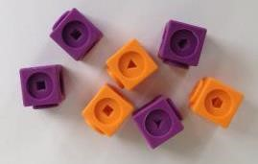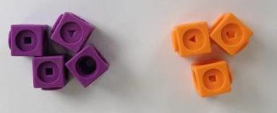 |  | Children represent the cubes/counters using circles or crosses. This could be represented in a part, whole model but does not have to be.  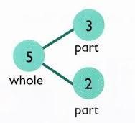  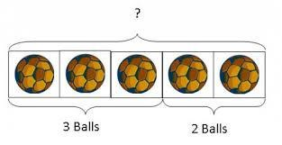  Use a bar model that encourages children to count on rather than counting all. | “Four is a part, six is a part, ten is the whole”  4+6=  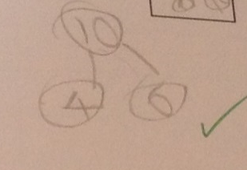  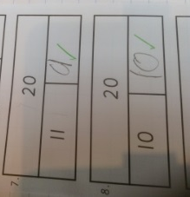
  Use pictures to add two numbers together as a group or in a bar.
    8 |   1
 | 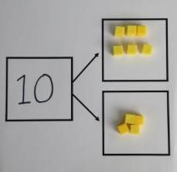  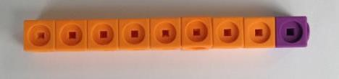 | Use cubes to add two numbers together as a group or in a bar.

Counting on a number line using numicon or cubes  Starting at the bigger number and counting  on | 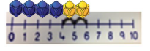  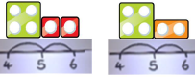  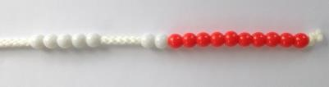  Start with the larger number on the bead string and then count on to the smaller number 1 by 1 to find the answer. | 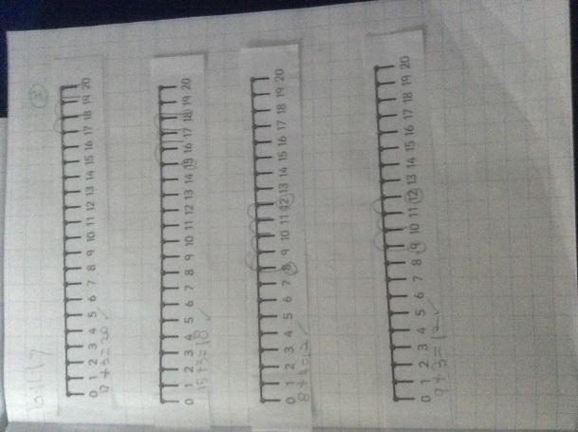  12 + 5 = 17  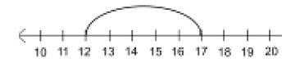  Start at the larger number on the number line and count on in ones or in one jump to find the answer.  Develop to counting on in H’s T’s and U’s  543+243 = 543 + 200 + 40 + 3 | 5 + 12 = 17  Place the larger number in your head and count on the smaller number to find your answer.  6+2=8  +1 +1  6 7 8  This would be children drawing their own number line.
Regrouping to make 10. | 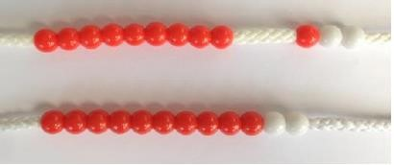  9+3  Use of bead strings or 10 frames  6 + 5 = 11  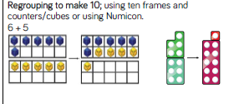 | Use pictures or a number line. Regroup or partition the smaller number to make 10.  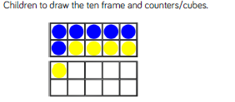 | 7 + 4= 11  If I am at seven, how many more do I need to make 10. How many more do I add on now?  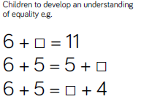

Regrouping to make 10 | 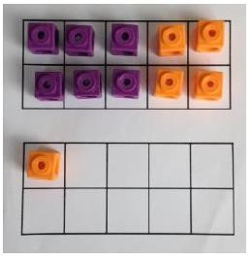  Start with the bigger number and use the smaller number to make 10. | 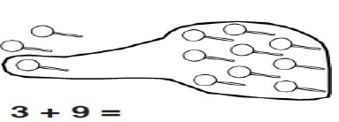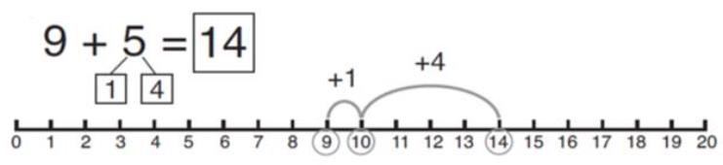
Using Tens and Ones to add | Tens and ones using dienes. Children to continue to develop the understanding of partitioning and place value. 41 + 8=  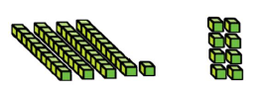  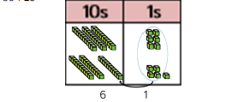  Children to continue to develop the understanding of addition through place value using dienes.  36+25 | Children represent dienes using their own pictures.  Children to represent their dienes using their own drawings. | 23 + 16 = 39  20 + 10 3 + 6  30 + 9
Adding three single digits | 4 + 7 + 6= 17  Put 4 and 6 together to make 10. Add on 7.  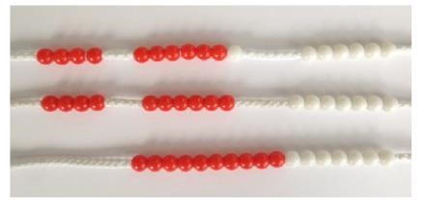  Following on from making 10, make 10 with 2 of the digits (if possible) then add on the third digit. |  +   +   + | 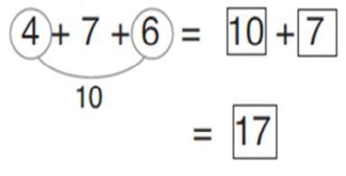  Combine the two numbers that make 10 and then add on the remainder.
  Add together three groups of objects. Draw a picture to recombine the groups to make 10.
Column method- no regrouping  (Partitioning and recombining – no exchanging) | 24 + 15=  Add together the ones first then add the tens. Use the Base 10 blocks first before moving onto place value counters.  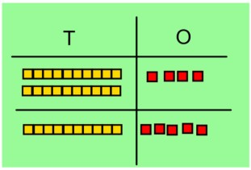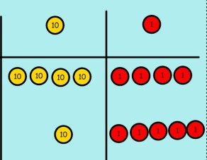 | After practically using the base 10 blocks and place value counters, children can draw the counters to help them to solve additions. | 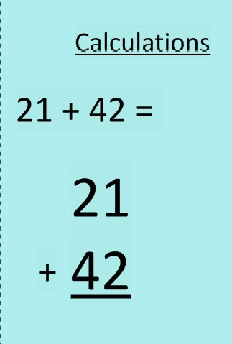  Step 1  21+42=  20+40= 60  1+2=3  63
  T | O
Column method- regrouping  (Partitioning with combining) | Make both numbers on a place value grid.  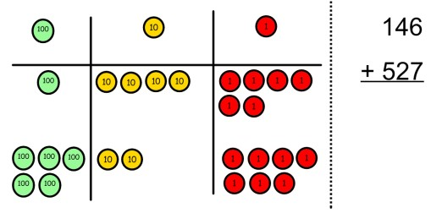  Add up the units and exchange 10 ones for one 10.  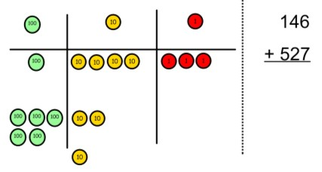  Add up the rest of the columns, exchanging the 10 counters from one column for the next place value column until every column has been added.  This can also be done with Base 10 to help children clearly see that 10 ones equal 1 ten and 10 tens equal 100.  As children move on to decimals, money and decimal place value counters can be used to support learning. | Children can draw a pictoral representation of the columns and place value counters to further support their learning and understanding.  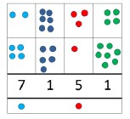 | Step 2  Start by partitioning the numbers before moving on  to clearly show the exchange below the addition.  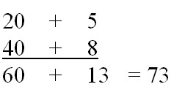  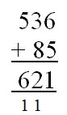  Step 3  As the children move on, introduce decimals with the same number of decimal places and different. Money can be used here.  Step 4  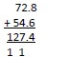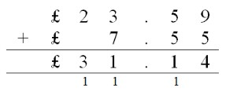  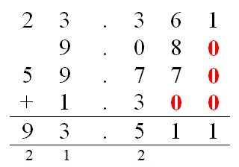
Mental methods | Mental methods should be developed to include increasingly large numbers, fractions and decimals. Methods should by supported by a range of modelling to include bars, numberlines.

Subtraction
Objective and Strategies | Concrete | Pictorial | Abstract
Taking away ones | Use physical objects, counters, cubes etc to show how objects can be taken away.      6 – 2 = 4 4 -2 = 2  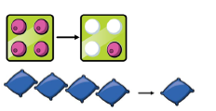 | Cross out drawn objects to show what has been taken away.  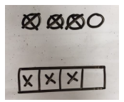  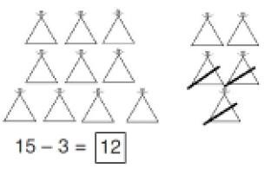 | 8 – 2 = 6  18 – 3 = 15
Counting back | 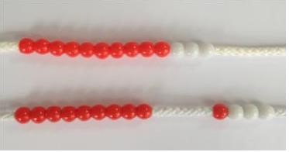  Make the larger number in your subtraction. Move the beads along your bead string as you count backwards in ones.  13 – 4  Use counters and move them away from the group as you take them away counting backwards as you go.  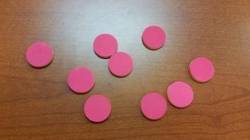  Put 6 cubes/counters along a number track, (to reach the number 6) and remove 2. Starting with 6 counting back 2. | Count back on a number line or number track  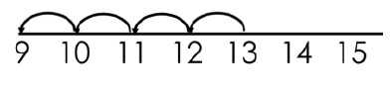  Start at the bigger number and count back the smaller number showing the jumps on the number line.  Step 1 57-23= 34  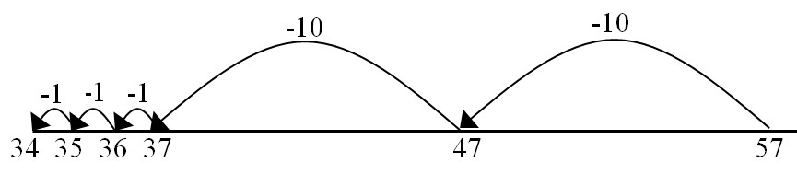  This can progress all the way to counting back using two 2 digit numbers.  Step 2 57-23=34  Children progress to subtracting bigger steps. Eg. They may be able to subtract 20 in one jump. | Put 13 in your head, count back 4. What number are you at? Use your fingers to help.  Children will draw their own number line independently and count back.

Find the difference | Compare amounts and objects to find the difference.  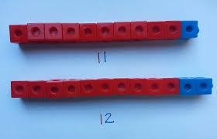  Use cubes to build towers or make bars to find the difference  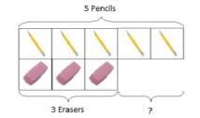  Use basic bar models with items to find  the difference | 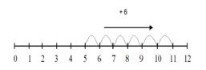  Count on to find the difference.  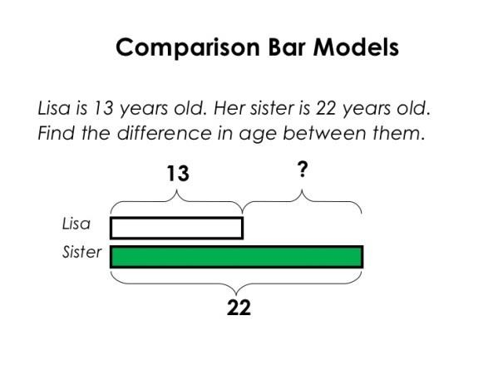  Draw bars to  find the difference between 2 numbers.  72 – 47 =?  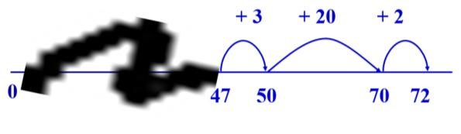 | Hannah has 23 sandwiches, Helen has 15 sandwiches. Find the difference between the number of sandwiches.  Find the difference between 8 and 5.  8 – 5, the difference is  Children to explore why 9-6=8-5=7-4 have the same difference.  23-15  Children will draw their own number line or bar model.
Part Part  Whole Model  (missing number calculations) | 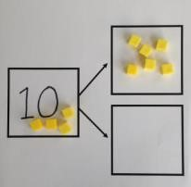  Link to addition- use the part whole model to help explain the inverse between addition and subtraction.  If 10 is the whole and 6 is one of the parts. What is the other part?  10 - 6 = | Use a pictorial representation of objects to show the part part whole model.   |   10  5  Move to using numbers within the part whole model.

Bar Modelling  (missing number calculations) | Link to addition- use the bar model to help explain the inverse between addition and subtraction.  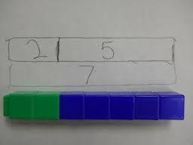 | Use a pictorial representation of objects within the bar model. | Move to using numbers within the part whole model.  23+?=56
Make 10 | 14 – 9 =  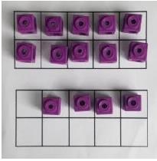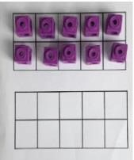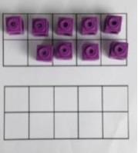  Make 14 on the ten frame. Take away the four first to make 10 and then takeaway one more so you have taken away 5. You are left with the answer of 9. | 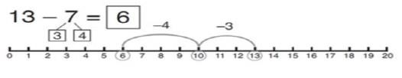  Start at 13. Take away 3 to reach 10. Then take away the remaining 4 so you have taken away 7 altogether. You have reached your answer. | 16 – 8=  How many do we take off to reach the next 10?  How many do we have left to take off?
Column method without regrouping | 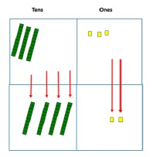  Use Base 10 to make the bigger number then take the smaller number away.  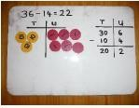  Show how  you partition numbers to subtract.  Again make the larger number first. | 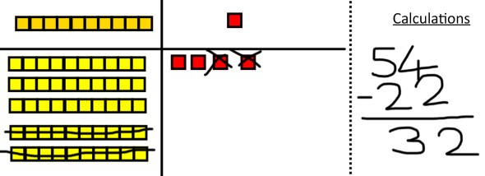  Draw the Base 10 or place value counters alongside the written calculation to help to show 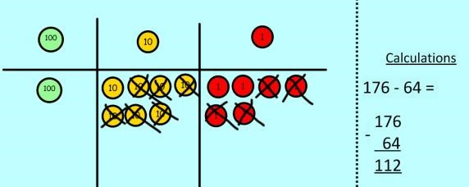 working. | 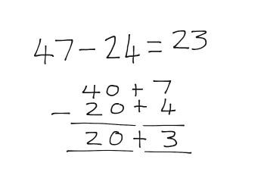  This will lead to a clear written column subtraction.  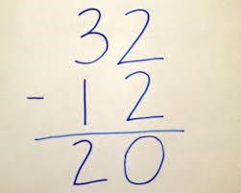

Column method with regrouping | Use Base 10 to start with before moving on to place value counters. Start with one exchange before moving onto subtractions with 2 exchanges.  Make the larger number with the place value counters  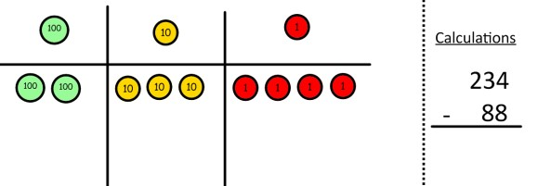  Start with the ones, can I take away 8 from 4 easily? I need to exchange one of my tens for ten ones.  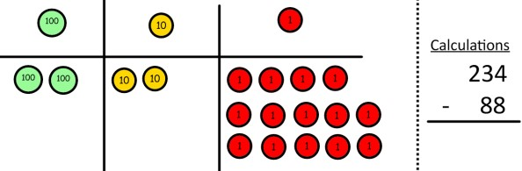  Now I can subtract my ones.  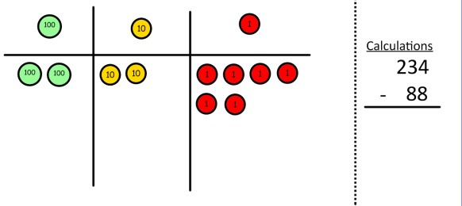  Now look at the tens, can I take away 8 tens easily? I need to exchange one hundred for ten tens. | 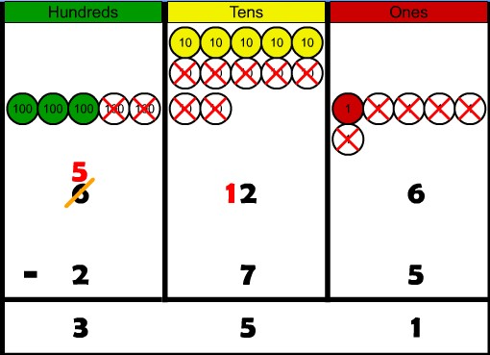  Draw the counters onto a place value grid and show what you have taken away by crossing the counters out as well as clearly showing the exchanges you make.  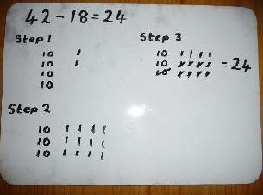  When confident, children can find their own way to record the exchange/regrouping.  Just writing the numbers as shown here shows that the child understands the method  and knows when to exchange/regroup. | 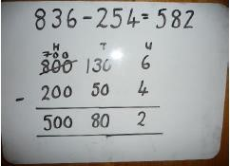  Children can start their formal written method by partitioning the number into clear place value columns.  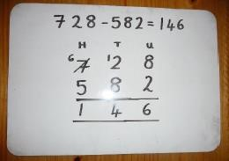  Moving forward the children use a more compact method.  This will lead to an understanding of subtracting any number including decimals.  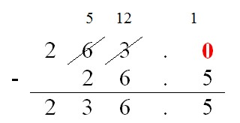
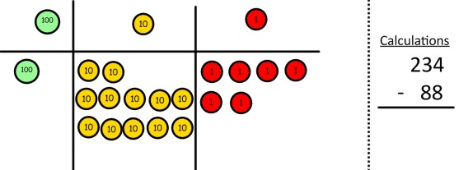
Now I can take away eight tens and complete my subtraction

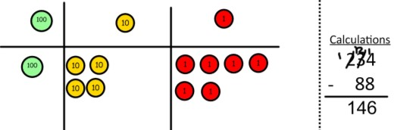

Show children how the concrete method links to the written method alongside your working. Cross out the numbers when exchanging and show where we write our new amount.

Mental methods | Mental methods should be developed to include increasingly large numbers, fractions and decimals.  Methods should by supported by a range of modelling to include bars, number lines as well as knowledge of complimentary facts

Key vocabulary for multiplication and division | Multiplication facts, deductions outside known facts, fact families, inverse, missing numbers, commutative, times tables, multiples, steps of, arrays, repeated addition, times, multiply, multiplied by, lots of, equal groups, groups of, grouping, sharing, double, same as, equal to, product, factor, quotient, dividend, divisor steps of, repeated subtraction, divide, divided by, half, halves, share equally, unequal groups

Multiplication
Objective and Strategies | Concrete | Pictorial | Abstract
Doubling | Use practical activities to show how to  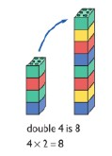  double a number.  Considering groups / lots of the same size | Draw pictures to show how to double a number emphasising groups/lots of the same amount/value  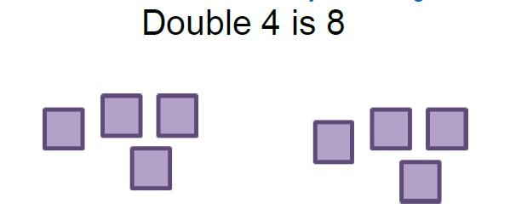  Double £6  £6 + £6 = £12 | 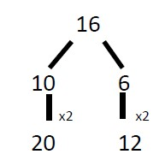  Partition a number and then double each part before recombining it back together.
Counting in  multiples  (develop the concept of scaling – 3 times taller/bigger/heavier etc) | 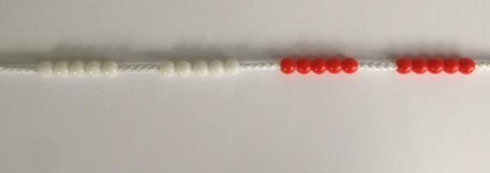  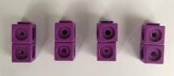  Count in multiples supported by concrete objects in equal groups. | 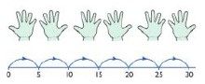  Use a number line or pictures to continue support in counting in multiples. | Count in multiples of a number aloud.  Write sequences with multiples of numbers.  2, 4, 6, 8, 10  5, 10, 15, 20, 25 , 30  Develop to counting in multiples of 6, 7, 9, 25, 100,  1000, 1/10, 1/100

Repeated addition  (Relating to ‘times’ and othre rich  vocabulary)  Jumping in groups | 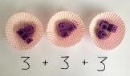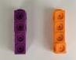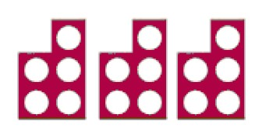  Use different  objects to add  equal groups.  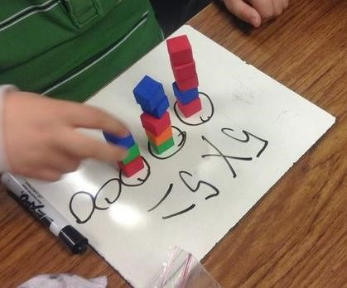  Pic of bar model |   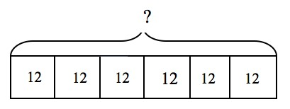  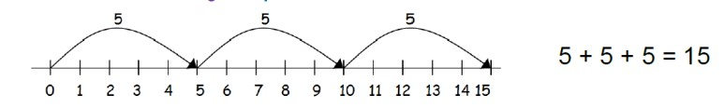 | Write addition sentences to describe objects and pictures.  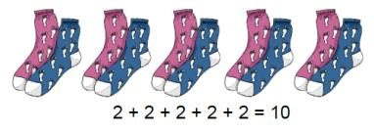
Arrays- showing  commutative multiplication | Create arrays using counters/ cubes to show multiplication sentences.  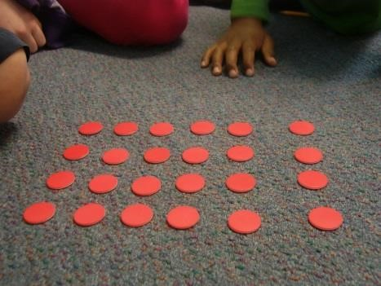  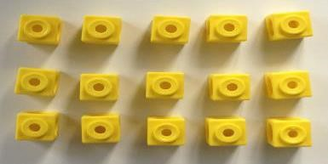 | 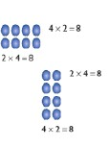  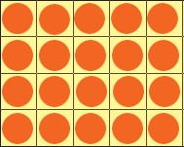  Draw arrays in different rotations  to find commutative multiplication sentences.  Link arrays to area of rectangles.  (can use numberline to add ‘lots of’) | Use an array to write multiplication sentences and reinforce repeated addition.  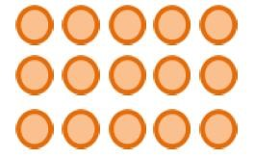  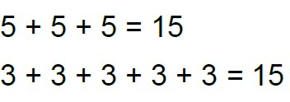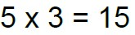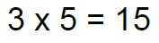

Multiply by 10, 100, 1000 | Pics of diens  2 x 10  (2 units becomes 2 rows of 10 ) | HTU columns  Extend to use of decimal place value | Able to recognise place  value shift  5x10= 50  16x100= 1600  1.5x10 = 15
Grid Method  (refer to groups and  lots) | Show the link with arrays to first introduce the grid method.  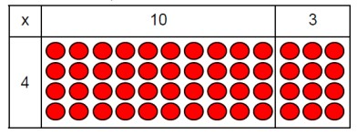  4 rows of 10 4 rows of 3  Move on to using Base 10 to move towards a more compact method.  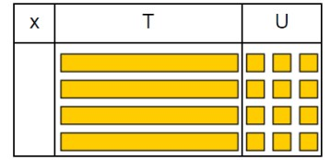  4 rows of 13  Move on to place value counters to show how we are finding groups of a number.We are multiplying by 4 so we need 4 rows.  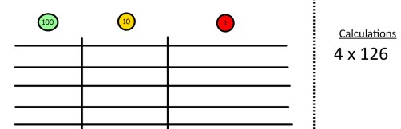  Fill each row with 126. | Children can represent the work they have done with place value counters in a way that they understand.  They can draw the counters, using colours to show different amounts or just use circles in the different columns to show their thinking as shown below.  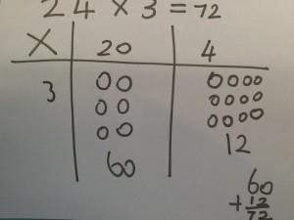 | Start with multiplying by one digit numbers and showing the clear addition alongside the grid.  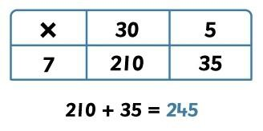  Moving forward, multiply by a 2 digit number showing the different rows within the grid method.  18 x 13  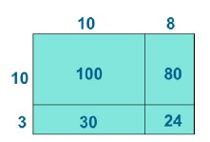

 | 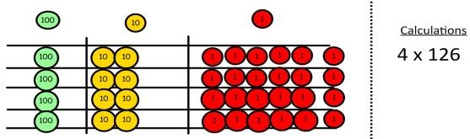  Add up each column, starting with the ones making any exchanges needed.  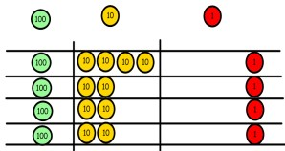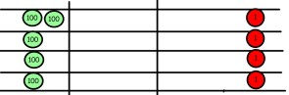  Then you have your answer. |  | 1342 x 18  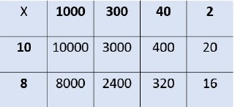  Children develop the use of blank arrays to solve problems like  2 x 5 = 160  5
  ? | 2
  150 | 10
Column  multiplication | Children can continue to be supported by place value counters at the stage of multiplication.  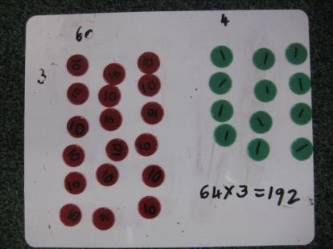  It is important at this stage that they always multiply the ones first and note down their answer followed by the tens which they note below. | Bar modelling and number lines can support learners when solving problems with multiplication alongside the formal written methods.  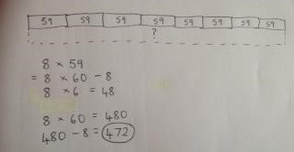  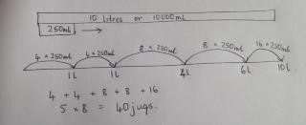 | Start with long  multiplication, reminding the children about lining up their numbers clearly in columns.  If it helps, children can write out what they are solving next to their answer.  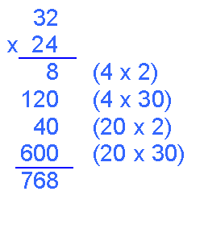
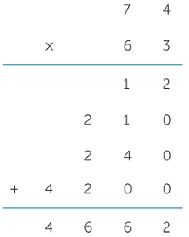

This moves to the more compact
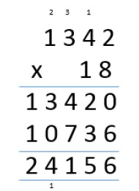
method.

Children will progress to using the compact method for multiplying decimals.

Division
Objective and Strategies | Concrete | Pictorial | Abstract
Sharing objects into  groups  Relate to  fractions  Eg ½ means 2 groups etc | 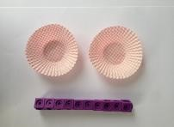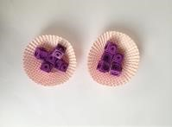  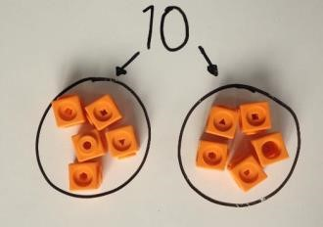  I have 10 cubes, can you share them equally in 2 groups? | Children use pictures or shapes to share quantities.    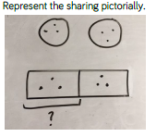 | Share 9 buns between three people.  9 ÷ 3 = 3  Children should be encouraged to use their times table facts
  8 ÷ 2 = 4
Division as  grouping  (How many 3s in 9?) | Divide quantities into equal groups. Use cubes, counters, objects or place value counters to aid understanding.  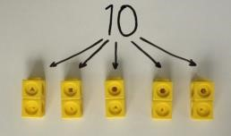  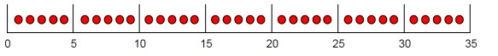  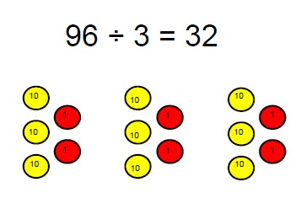 | 10 ÷ 2 = 5  IIIII  IIIII | Use a number line to show jumps in groups. The number of jumps equals the number of groups.  12÷3 (how many jumps?)  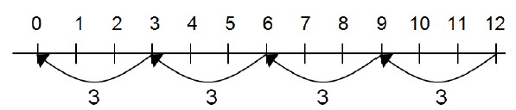  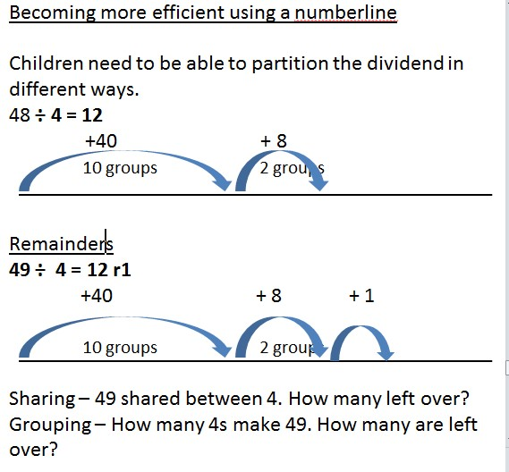
Division as repeated Subtraction | 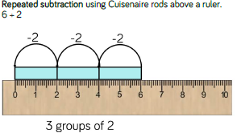 | 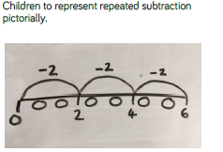 | 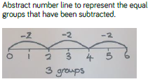
Division -Use of the Bar model |  | Develop the use of the bar model  25 ÷ 5 = 5  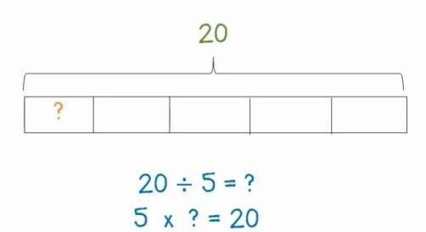  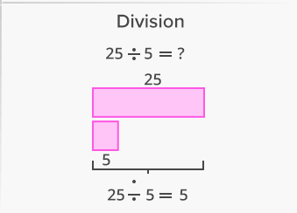

Division within arrays  (solve missing  number calculations)  Also relate to  fractions – eg 1/3  means 3 (3rows) | Link division to multiplication by creating an array and thinking about the  number sentences that can be created.  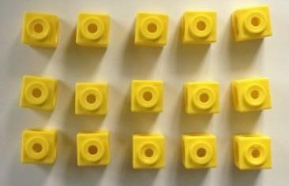  Eg 15 ÷ 3 = 5 5 x 3 = 15  15 ÷ 5 = 3 3 x 5 = 15 | 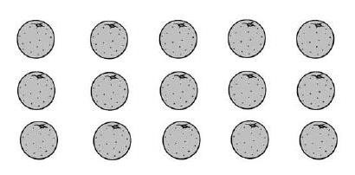Draw an array and use lines to split the array into groups to make multiplication and division sentences.  Develop forward to using blank arrays 18÷6 =  ?  6  Link to fractions 1/8 of 32  ?  8  Develop 3/8 will be three of the groups of 1/8 | Find the inverse of multiplication and division sentences by creating four linking number sentences.  7 x 4 = 28  4 x 7 = 28  28 ÷ 7 = 4  28 ÷ 4 = 7  Use to solve missing  number problems  ? ÷ 4 = 9 9 x 4 = ?
  18
  32

Division with a remainder | 14 ÷ 3 =  Divide objects between groups and see how much is left over  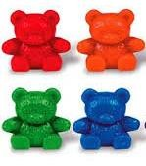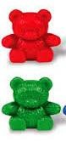 | Jump forward in equal jumps on a number line then see how many more you need to jump to find a remainder.  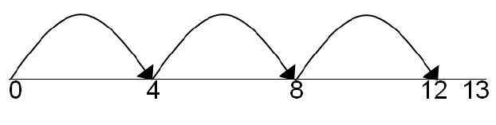  Draw dots and group them to divide an amount and clearly show a remainder.  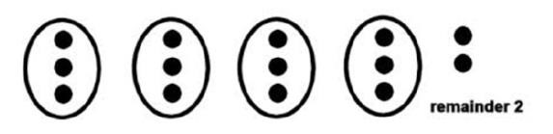 | Complete written divisions and show the remainder using r.  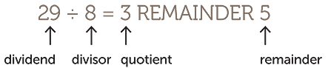
Short division | 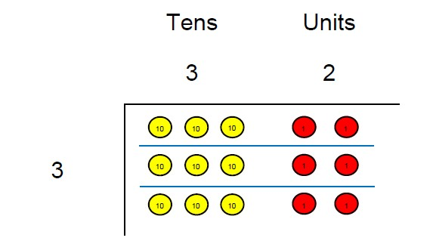  96÷3  Use place value counters to divide using the bus stop method alongside  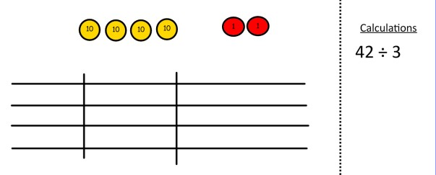  42 ÷ 3= | Students can continue to use drawn diagrams with dots or circles to help them divide numbers into equal groups.  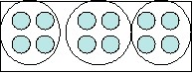  Encourage them to move towards counting in multiples to divide more efficiently. | Begin with divisions that divide equally with no remainder.  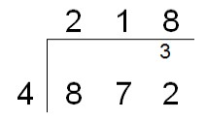  Move onto divisions with a remainder.  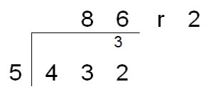
 | Start with the biggest place value, we are sharing 40 into three groups. We can put 1 ten in each group and we have 1 ten left over.  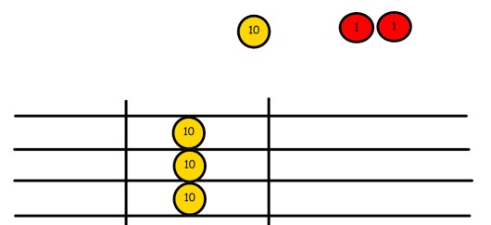  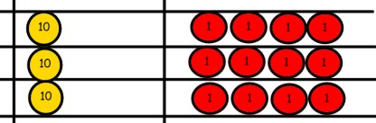  We exchange this ten for ten ones and then share the ones equally among the groups.  We look how much in 1 group so the answer is 14. | 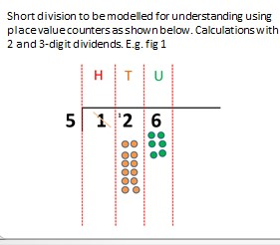 | Finally move into decimal places to divide the total accurately.  

