

Prior Learning

Knowledge Building Blocks
Pupils will know that:
- God created the universe
- The Earth and everything in it are important to God
- God has a unique relationship with human beings as their creator
- humans should care for the world because it belongs to God
- God the creator cares for the creation, including human beings
- The bible tells the story ( in Genesis 3 ) about how humans spoiled their friendship with God
(sometimes called the Fall)

Salvation
Why do Christians call the day Jesus died ‘Good Friday’?
Year 3 - RE
Subject Vocabulary
Old Testament |  | The first part of the bible that tells stories that happened before Jesus was born.
New testament |  | The New Testament, is the second and later of the two sections of the Christian Bible
Salvation |  | Deliverance from sin - believed by Christians to be brought about by faith in Christ.
Relationship |  | To be related or connected to someone or something.
Commands |  | Rules or orders.
Worship |  | To respect or honour somebody or something.
disciple |  | a personal follower of Christ during his life.
crucifix |  | an image of a cross with a figure of Christ on it
Holy Week |  | The week before Easter, starting on Palm Sunday.
Palm Sunday |  | Christ's entry into Jerusalem is celebrated by processions in which branches of palms are carried.
Good Friday |  | This was the day that Jesus was arrested and put to death
Easter Sunday |  | Easter Sunday marks Jesus's resurrection.
resurrection |  | Jesus’s return to life on the third day after his death
General Vocabulary
Spirituality | To have a relationship with God.
Symbol | An object or picture that represents something else.
Text | A piece of writing.
Reflect | To think quietly and deeply about something.

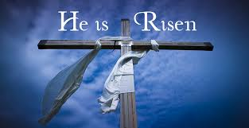
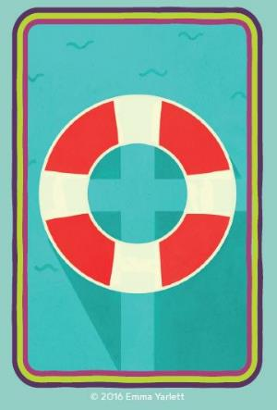

Key Knowledge
- Order Creation and Fall, Incarnation, Gospel and Salvation within a timeline of the Bible’s ‘big story’.
- Christians see Holy Week as the culmination of Jesus’ earthly life, leading to his death and resurrection.
- The various events of Holy Week, such as the Last Supper, were important in showing the disciples what Jesus came to earth to do.
- Christian’s today trust that Jesus really did rise from the dead, and so is still alive today.
- Christians remember and celebrate Jesus’ last week, death and resurrection

Key Skills
To develop skills of listening and thinking about what people believe?
To express our own ideas about religious beliefs and spirituality.
To keep an open mind about how we feel.
To look at how people act because of religious beliefs.
To show how religious beliefs affect people’s lives.
Offer suggestions for what the texts about the entry into Jerusalem, and the death and resurrection of Jesus might mean.

